EXPT NO:7 | IMPLEMENT ADVANCED CHART TYPES USING TABLEAU AND  POWER BI
DATE: 14.08.2026

PRE-LAB QUESTIONS

1. What is data integration in the context of Business Intelligence (BI)?
Data integration is the process of combining data from multiple sources into a unified data model.
It allows different datasets to be analyzed together.
It helps create comprehensive reports and dashboards.
It provides better and more meaningful business insights.

2. Explain the difference between a join and a data blend in Tableau.
A join combines tables using a common field within the data source.
A data blend combines data from different data sources using a common linking field.
Joins generally combine data at the data-source level.
Data blending is useful when data comes from separate sources.

3. What are relationships and cardinality in Power BI's data model?
A relationship connects two tables using a common field.
Cardinality describes how records in the tables are related.
Common types include one-to-many and many-to-many.
It helps Power BI correctly model and analyze related data.

4. Why is data quality crucial when integrating data from different sources?
Good data quality ensures that data is accurate and consistent.
Field names and values should follow consistent naming conventions.
Data types such as numbers and dates should also be correct.
This prevents errors and improves the accuracy of analysis.

5. Name two common challenges encountered during data integration.
One common challenge is inconsistent or mismatched field names between datasets.
Another challenge is having different data types or formats.
Missing values can also affect data integration.
These issues should be cleaned before analysis

IN-LAB EXERCISE:
OBJECTIVE:
To connect, combine, and model data from multiple sources in Tableau and Power BI and create a unified, comprehensive dashboard for holistic analysis.

PROCEDURE:
- Data Collection:
  - Import two datasets:
    - Dataset 1: Sales Data (CSV) → Order ID, Order Date, Region, Sales Amount
    - Dataset 2: Regional Sales Targets (Excel) → Region, Sales Target, Target Year
- Data Preparation and Transformation:
  - Clean datasets (e.g., standardize "N. America" → "North America"). • Ensure correct data types (numeric for Sales, date for Order Date).
  - Handle missing values appropriately.
- Data Integration and Modeling:
  - Tableau: Create a join/relationship on the Region field in the Data Source pane.
  - Power BI: Use the Model view to create a relationship on Region; define cardinality (e.g., many-to-one).
- Create Calculated Fields for Comparison:
  - Target Achievement % = (SUM(Sales) / SUM(Sales Target)) * 100
  - Sales vs. Target Variance = SUM(Sales) - SUM(Sales Target)
- Design a Comprehensive Dashboard:
  - Combine visuals from both sources.
  - Add KPI cards: Total Sales, Overall Target Achievement %.
  - Use gauge/bullet charts for region-wise target performance.
  - Combined bar chart: Actual Sales vs. Target by Region.
  - Map visualization: Sales vs. Target Variance by region.
- Validate Data Integrity:
  - Cross-check joined data for accuracy.
  - Ensure dashboard filters correctly update visuals.
- Publishing and Sharing:
  - Tableau: Publish to Tableau Public or Server.
  - Power BI: Publish to Power BI Service and share.
Experiment Datasets:
  - Dataset 1: Retail Sales Data (CSV) → Order ID, Order Date, Region, Sales
  - Dataset 2: Regional Sales Targets (Excel) → Region, Sales Target, Target Year

POWER BI DASHBOARD :
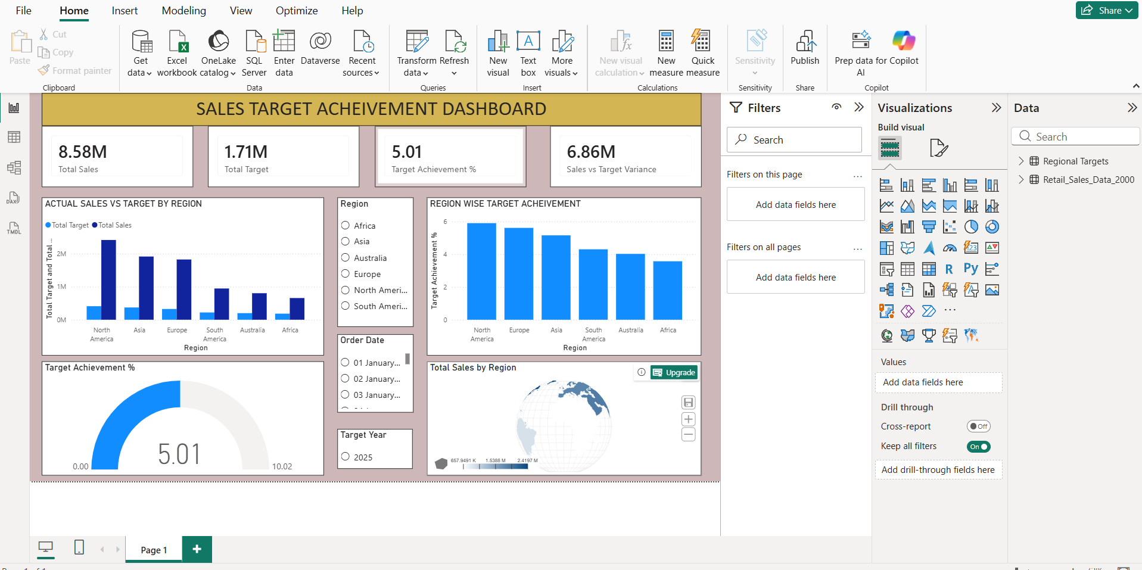
TABLEAU DASHBOARD :
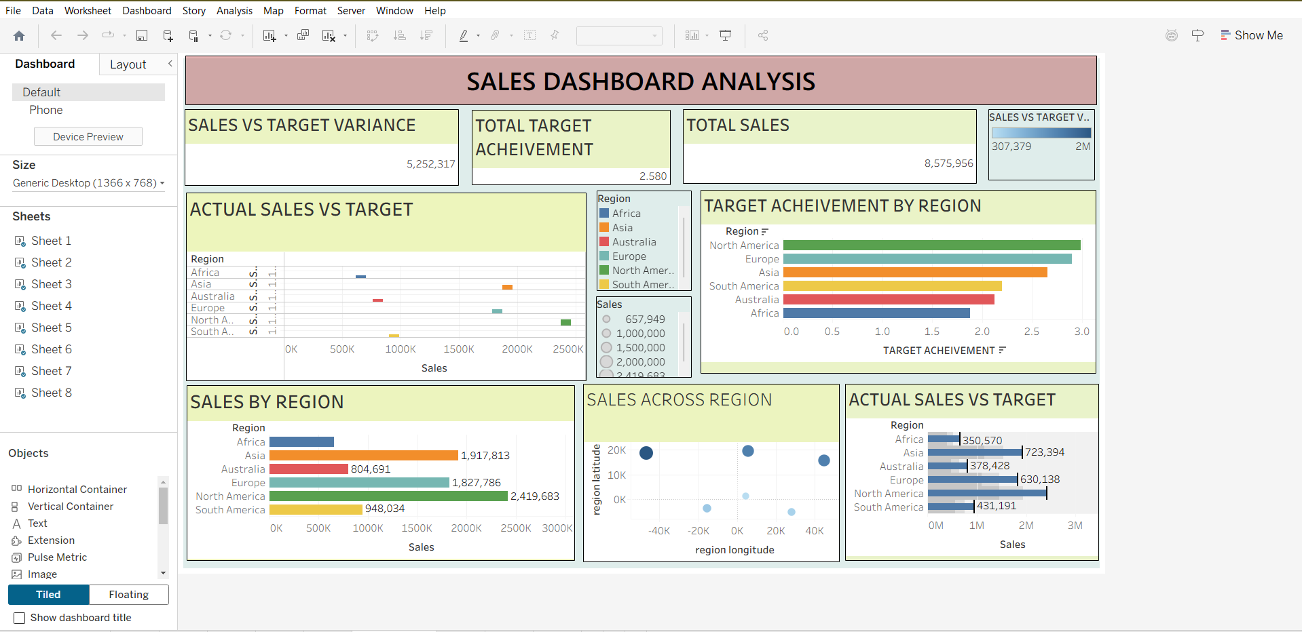

POST-LAB QUESTIONS
1. How did integrating the sales targets data provide a more complete analytical picture than using the sales data alone?
Integrating sales targets allowed actual sales to be compared with planned targets.
It helped identify regions performing above or below their targets.
The dashboard could calculate target achievement and variance.
Therefore, it provided more useful regional performance insights.
2. Describe the type of join or relationship you used to combine the two datasets and explain why it was appropriate.
The two datasets were connected using the Region field.
A many-to-one relationship was used in Power BI.
Multiple sales records can correspond to one regional target record.
This relationship is suitable for comparing sales with regional targets.
3. What challenges, if any, did you face regarding data granularity or mismatched keys between the two sources?
The region names needed to be consistent in both datasets.
For example, "N. America" had to be standardized to "North America".
Different data granularity or mismatched keys can cause incorrect relationships.
The datasets were cleaned before creating the relationship.
4. How can creating variance calculations help a business manager make better decisions?
Variance shows the difference between actual sales and the sales target.
A positive variance indicates sales are above the target.
A negative variance indicates sales are below the target.
Managers can use this information to identify areas needing improvement.
5. What other data source could you integrate to further enrich this analysis, and what new insights might it provide?
Marketing campaign data could be integrated with the sales data.
It could show whether marketing campaigns increased regional sales.
Managers could compare campaign activity with sales performance.
This would provide additional insights for improving marketing strategies.

RESULT:

The retail sales and regional targets datasets were successfully connected, cleaned, and integrated in Tableau and Power BI. Relationships between the sources created a unified data model. The dashboard visualized sales performance against targets, enabling variance analysis and providing insights into regional performance not possible with a single data source.

ASSESSMENT

Description |  | Max Marks | Marks Awarded
Pre Lab Exercise |  | 5
In Lab Exercise |  | 10
Post Lab Exercise |  | 5
Viva |  | 10
 | Total | 30
 | Faculty Signature

